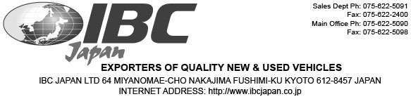

Ian Houghton
Bernian Enterprises Ltd
USER ID: 23852

November 8, 2019
Dear Ian Houghton:
This will serve as your notification that IBC Japan will guarantee full refund of your payment for the 2010 SUZUKI JIMNY with Chassis # JB43W-450378 if after arrival to New Zealand the vehicle won’t pass compliance.
The refund process will be based on IBC’s refund terms and conditions online at www.ibcjapan.net which entails we will be deducting 10% admin fee and possible bank charges from the total refundable amount.
Do let us know how else we may be able to assist you.

Sincerely,
Hanami Yuri
Account Manager | IBC Japan Ltd.
P: P: +81 366359355 ext. 354
E: h.yuri@ibcjapan.co.jp
W: www.ibcjapan.net

