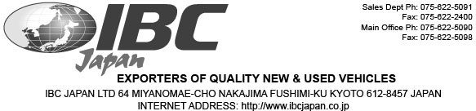

MESSRS:Antti Salminen

PROFORMA INVOICE
Invoice No: 1457841Invoice Date: 7/8/2019

Niittykorventie 20,28660 Pori, Finland
+358-44-5560206

SHIPPED PER : 0From: Japan To: Finland
SAILING ON OR ABOUT: TBD
TERMS: T/T

Description

Mark & NO. | MAKE | MODEL | YEAR CHASSIS KMS Amount
1 | MITSUBISHI | AIRTREK | 2003 CU2W-0303846 86,135 JPY 200,000
2 | HONDA | LEGEND | 2005 KB1-1005638 100,871 JPY 250,000
3 | TOYOTA | CALDINA | 2006 ST246-0009197 122,024 JPY 320,000
4 | MITSUBISHI | COLT | 2005 Z27A-0200671 86,910 JPY 200,000

TOTAL: 4 UNIT(S)
Total: JPY 970,000
MARK & NO.: Finland/ Antti Salminen

MADE IN JAPAN NO.1

Payment Instructions
Bank Name: MUFG Bank , Ltd.
Branch Name: Fushimi, Kyoto, Japan (code 508)
Bank Address: 276 Furoya-cho, Fushimi-ku, Kyoto, Japan 612-8058
Account Name: IBC Japan Ltd
Account Number: 0418090
Swift Code: BOTKJPJT Fushimi Branch

Bank Name: MUFG Bank , Ltd.
Branch Name: Fushimi, Kyoto, Japan (code 508)
Bank Address: 276 Furoya-cho, Fushimi-ku, Kyoto, Japan 612-8058
Account Name: IBC Japan Ltd
Account Number: 0418090
Swift Code: BOTKJPJT Fushimi Branch

