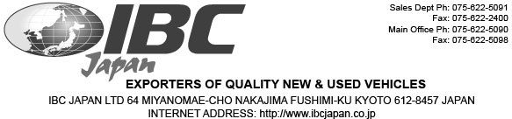

MESSRS:Judy Ndichu PO Box 8225-00100

Mombasa, Kenya
PROFORMA INVOICE
Invoice No: 8298061Invoice Date: 7/23/2019

SHIPPED PER : 0From: Japan-Any Port To: Kenya, Unassigned
SAILING ON OR ABOUT: TBD
TERMS: T/T

Description

Mark & NO. MAKE MODEL YEAR CHASSIS KMS Amount

1 VOLKSWAGEN GOLF 2012 WVWZZZ1KZCW290561 63,688 USD 5,300

TOTAL: 1 UNIT(S)
Total: USD 5,300

MARK & NO.: Judy Ndichu Kenya

MADE IN JAPAN NO.1

Payment Instructions:

Bank Name: MUFG Bank , Ltd.
Branch Name: Fushimi, Kyoto, Japan
Bank Address: 276 Furoya-cho, Fushimi-ku, Kyoto, Japan 612-8058
Account Name: IBC Japan Ltd
Account Number: 0016838
Swift Code: BOTKJPJT Fushimi Branch

