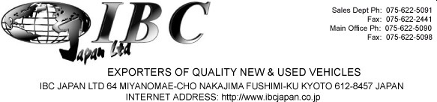

INVOICE

DATE: April 27, 2019
MESSRS Taylor Whittaker Enterprises, LTD.
C/O Neil Martin 125 Maxfield Ave Kingston 10 ORDER NO: 190427843798
Jamaica WI Kingston, Jamaica
212-781-5806

SHIPPED PER: | Salvia Ace - KB | SAILING ON OR ABOUT: | 4/12/2019
FROM: | Japan TO: Kingston, Jamaica | TERMS: | On Account

MARKS & NOS DESCRIPTION & QUANTITY AMOUNT

USED MOTOR CAR CIF in USD

No. | Year | Make | Model | Color | CC | Mileage | Seat Capacity | Doors | Chassis | CIF
1 | 2014 | NISSAN | LATIO | PEARL | 1200 | 17,210 | 5 | 4 | N17-700422 | 4,100

IBC Japan Ltd.

Thank you for buying an IBC vehicle, Payment can be made into the following account: The Bank of Tokyo-Mitsubishi Ltd (Code 005) Fushimi Branch (Code 508)
Bank Address: 276 Furoya-cho, Fushimi-ku, Kyoto, Japan 612-8058 Account Name: IBC Japan Ltd
Account Number: 0016838 (savings) Swift Code: BOTKJPJT Fushimi Branch

