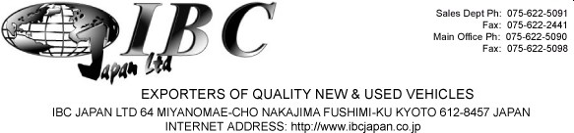

INVOICE

DATE: April 22, 2019
MESSRS Kintsugo Auto Imports and Sales Limited
Attn: Ronald Jarrett ORDER NO: 1904777506
23 Haining Road, Kingston 5 Jamaica, BWI.
Tel No: 1876-616-8616
Email: kintsugiautoimports2019@gmail.com

SHIPPED PER: | Unassigned | SAILING ON OR ABOUT: | To be announced.
FROM: | Japan TO: Kingston, Jamaica | TERMS: | On Account

MARKS & NOS DESCRIPTION & QUANTITY AMOUNT

USED MOTOR CAR CIF in USD

No. | Year | Make | Model | Color | CC | Mileage | Seat Capacity | Doors | Chassis | TOTAL
1 | 2016 | TOYOTA | MARK X | DARK BLUE | 2,500 | 46,080 | 5 | 4 | GRX130-6097159 | 8,119

IBC Japan Ltd.

Thank you for buying an IBC vehicle, Payment can be made into the following account: The Bank of Tokyo-Mitsubishi Ltd (Code 005) Fushimi Branch (Code 508)
Bank Address: 276 Furoya-cho, Fushimi-ku, Kyoto, Japan 612-8058 Account Name: IBC Japan Ltd
Account Number: 0016838 (savings) Swift Code: BOTKJPJT Fushimi Branch

