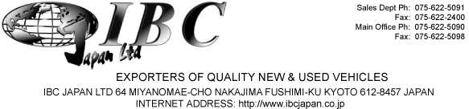

PROFORMA INVOICE

MESSRS

PETER RONO NGOCHOCH

KENYA PIPELINE COMPANY OFFICE CHANGAMWE, MOMBASA KENYA TEL: 0722519018
DATE: ORDER NO.

Oct, 08, 2019
191004868619

SHIPPED PER:
FROM:

To be Announced Nagoya

TO: Mombasa, Kenya
SAILING ON OR ABOUT:

TERMS:

DESCRIPTION & QUANTITY AMOUNT

Year Make | Model | Grade |  | Chassis No | Engine No. | Color
2012 SUBARU | IMPREZA | 1.6I-L |  | GP2-006275 | FB16-P434854 | Gray
Doors | Trans. | P/S | P/W | A/C | CC Fuel | Drive
5 Door | Auto | Yes | Yes | Yes | 1600 Petrol | RH.D

MARK & NO.
FOB Price
Ocean Freight Service

3,679.68 USD
1,220.32 USD

TOTAL FOR UNITS

4,900.00 USD

REMARKS
- Bank Name: MUFG Bank , Ltd.

- Branch Name:
- Bank Address:
- Account Name:
- Account Number:
- Swift Code:
Fushimi, Kyoto, Japan
276 Furoya-cho, Fushimi-ku, Kyoto, Japan 612-8058 IBC Japan Ltd
0016838
BOTKJPJT

IBC Japan Ltd.

