KAP – STRATEGIC PARTNERS: Process on Confirmation, Invoicing and MR2A Releasing of Vehicles

CONFIRMATION OF VEHICLES

- A new account "KAP - Strategic Partner" will be created on Insight wherein vehicles that will lbe sold to Strategic Partners in NZ would be confirmed.
Requirements:
Currency: NZD Currency Account
Market: 65,000 – 1,535 NZD (subject for review, proposal for OFS is 1,200)

- Upon confirmation of vehicles on KAP - SP account, price should be at SIV or SF whichever is lower.
IBC Pricing Structure:
SIV = Purchase Price + FOB fee + OFS
Sales Floor (SF) = Car Cost + FOB fee + OFS

- KAP Accounts will enter the data into Xero with pricing provided by Glenn or Chris.

- Once vehicles are confirmed to “KAP – Strategic Partner” Account, vehicles will be automatically imported to Motorcentral. (KAP Accounts c/o Aiko will inform Rajeesh of developers the new CID and account for importation).

- KAP Accounts c/o Aiko will manually update the pricing on Motorcentral based on the price negotiated by Glenn and Chris to Strategic Partner.

Note: CFS will need to be notified of the vehicle’s value owed to KAP when the vehicle is added to the floor plan and fin power. Any changes in motorcentral to the value of the vehicle, cfs need to be notified.

- At the same time, KAP Accounts will enter data into Xero with pricing provided by Glenn and Chris (price will be the same as Motorcentral).

- Please see next page on the steps of Selling Out Vehicles on MC (KAP Accounts are currently doing this).

INVOICING

- OSL Accounts will be sending an invoice to KAP at IBC CIF (NZD) upon shipment.

- Once KAP receives the NZ Shipment data, KAP will prepare an invoice at Sales Price thru Xero and send to the Strategic Partner/ Glenn/ Chris.

MR2A RELEASING

- Customer sends release request to kapaccounts (for KAP releases) or atnzaccounts (for ATNZ releases) or mr2amgmt (KAP/ATNZ releases).

- Approval from Glenn is needed.

- kapaccounts (for KAP releases) or atnzaccounts (for ATNZ releases) or mr2amgmt (KAP/ATNZ releases) to send release email to compliance.

- Compliance to release MR2A (compliance center should wait for kapaccounts or atnzaccounts or mr2amgmt email before releasing the MR2A).

- On the same day of release, Accounts sends invoice for the remaining balance due of the released vehicle.
  - Accounts follows up payment every TTH for unpaid released MR2As and PPSRs
  - Accounts sends SOA every Friday for unpaid released vehicles.
  - Accounts sends every TTH ATNZ and KAP Consolidated AR to Glenn and Chris
  - Cash Sales made by SP - Accounts puts Strategic Partner on a no release of mr2as if the TTH are not paid on time.
  - Sales on Finance made by SP - Accounts will email CFS accounts (Gretchen/ Shane) so that on settlement of finance from CFS, monies owed to KAP are paid directly to KAP and not to SP.

Note: Strictly no PPSRs will be removed until full payment for invoices including admin fees, interest charges and registration fees unless approved by Glenn(KAP)/ Shane(CFS)
- Cash Sales – KAP remove PPSR
- Financing – KAP remove PPSR and CFS put PPSR on the vehicles

Payment directly to KAP by CFS on finance vehicles, on the date the loan is advanced.

STEPS IN SELLING OUT OF INVENTORY/STOCKS IN MC

- Search the vehicle using Chassis/VIN #. Double click to show the vehicle details.

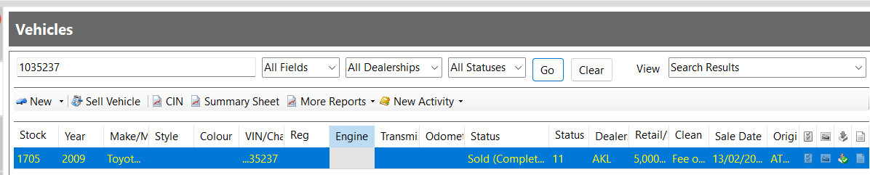

- Click “SELL VEHICLE” tab and fill in the details of the sale.

- General – to update the Seller name. Tick check on the invoice date.

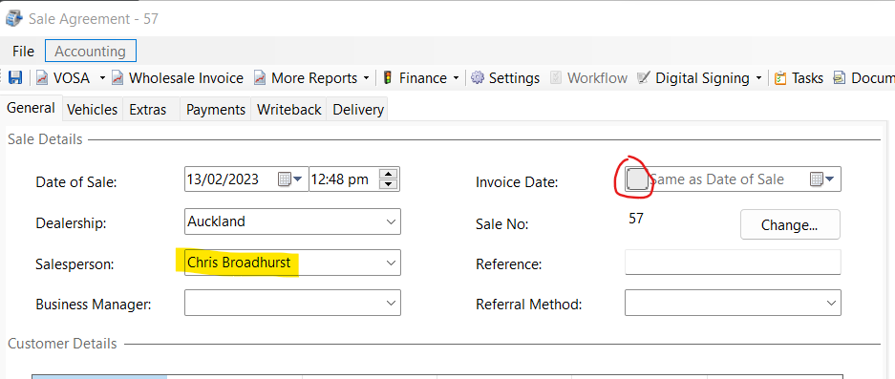

- General – add customer (bottom right). Then fill in customer details. Save and close.

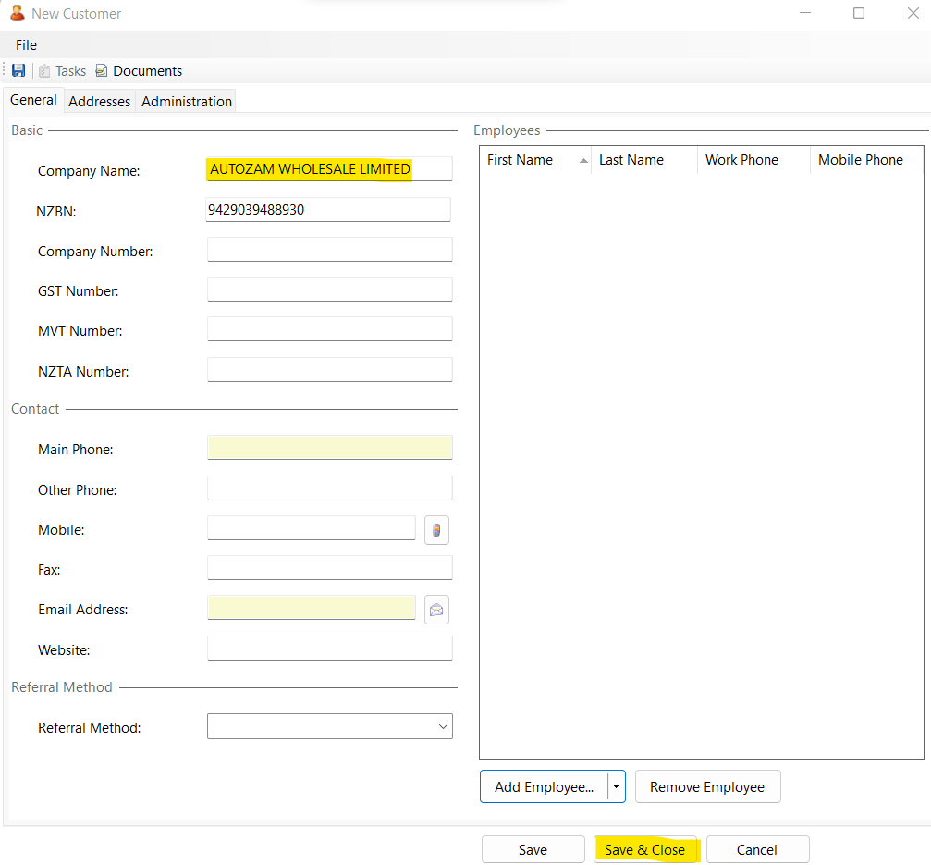

- Vehicles – to update the selling price.

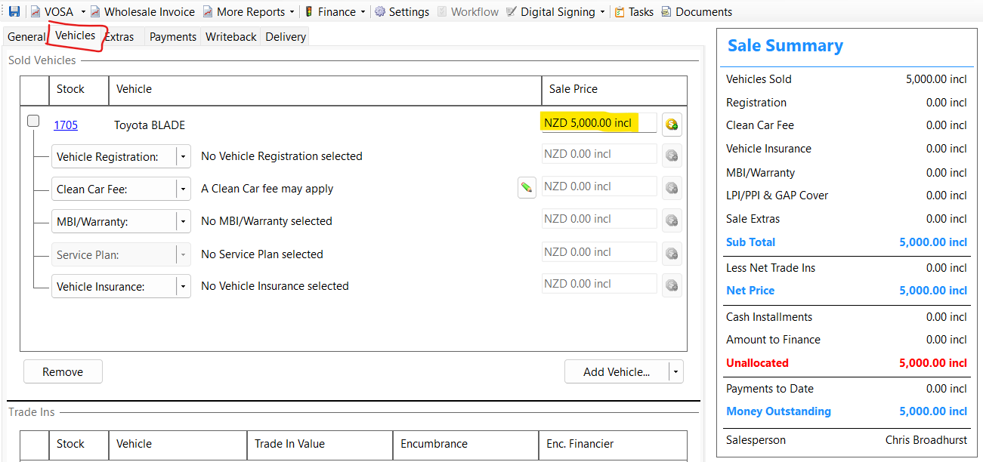

- Update the Sale Status and Sale Type. Then click Save and Close

Sale Status – needs to be firstly in progress changing to finalized only once funds have been received
- In Progress – status if no payment yet
- Completed -
- Finalised – status if the vehicle has been fully paid

Sale Type – Wholesale

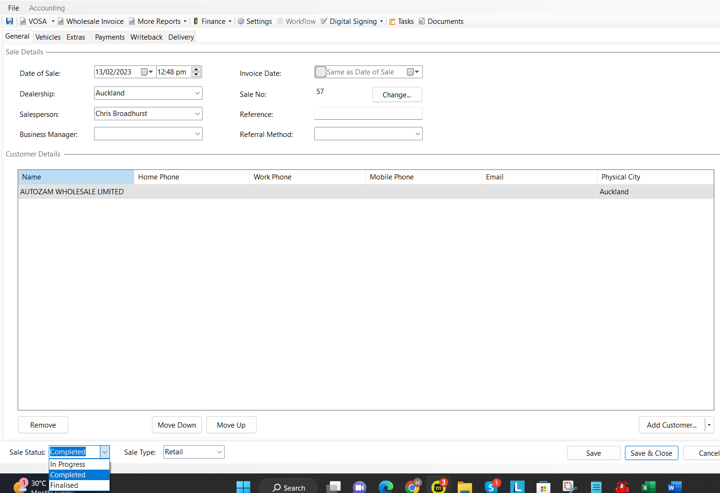

- Under Administration Tab, double check if sale details are correct.

Note: Selling price should only include Clean Car Fees if KAP has already paid the fee



