IBC JAPAN LTD
64 MIYANOMAE-CHO
NAKAJIMA
FUSHIMI-KU
KYOTO
JAPAN

8th February 2023

Dear Sir/ Madam;
RE: GP53112277 Honda Fit Hybrid – Mr Iqbal Khalid
I, Mr. Michael Clarke, Team Leader of the Logistics Department of Wallenius Wilhelmsen Solutions UK Ltd, confirm the below to be true to the best of my knowledge.
In December 2022 Mr Khalid sent his Export Certificate for the subject line vehicle along with the Sales invoice.
These were subsequently posted back to him shortly after however Mr Khalid has never received them.
The assumption here is that they have been misplaced within the postal system. Unfortunately, these were not posted by recorded delivery, therefore we have no way of tracking these.
Please accept our apologies on the matter.

Kind Regards
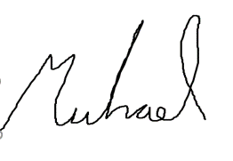
Michael Clarke
Team Leader Logistic Solutions UK
Michael.clarke@walwil.com
armacupeu@walwil.com

