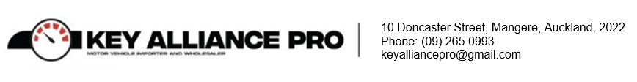
10 January 2023

To Whom it May Concern

Vehicle Details:

Chassis No. | Year/Make/Model
ANE11-0030475 | 2006 | TOYOTA | WISH Silver

We are the legal owner of the above-mentioned vehicles. After reasonable effort to locate the documents at our KAP Office, the document is nowhere to be found. We would appreciate it if you could kindly print/re-print the MR2A’s for us.

Many thanks,

Yours Sincerely,

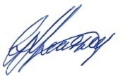

Glenn Keatley
General Manager
Key Alliance Pro Ltd

