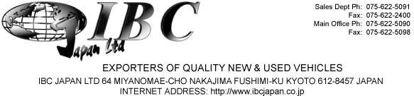

 | INVOICE
 |  | DATE Nov, 19, 2019
MESSRS Paul Jjombwe .  Plot 577, Block 15 Nsambya Road, P.O. Box 30086, Kampala, |  | INVOICE NO. 86382943093
COUNTRY UGANDA
SHIPPED PER: Orion Leader-YK |  | SAILING ON OR ABOUT: 7/20/2019
FROM: Yokohama | TO: Mombasa, Kenya | TERMS: T/T
 | DESCRIPTION & QUANTITY | AMOUNT
 | USED MOTOR CAR(S) | CIF Mombasa in USD
1 MERCEDES-BENZ C180 KOMPRESSOR | 2005 WDC2030462R207287 | SILVER ¥1,000
 | ONE UNIT(S) TOTAL | TOTAL: ¥1,000
MARK & NO.
NO MARK

IBC Japan Ltd.

