IBC JAPAN LTD.
STANDARD OPERATING PROCEDURES
Controlled No.: SOP-001-102019
Dated 24 October 2019 Rev. 0

Table of Contents Pages

- Stock Inventory 2 - 3

- Stock Inventory Customers
- Stock-Inventory Japan (New) CID; 39
- Stock-Inventory Japan CID; 77
Pre-Sold Stock Inventory CID; 680850;

- Pricing
- Pricing 4
  - Auction Price
  - Auction Fee
  - Purchase Price
  - Car Cost

- IBC Cost Details 4 - 5
  - “Estimated” Cost Details;
  - “Accounting” Cost Details;

3. IBC Pricing for Customers 5
a. Asking Price;
b. Sales Floor;
c. SIV (Stand in value)
d. Break Even;

- Vehicle Confirmation 6

History Log
Date issued/Revision | Description | Author
24 October 2019 | Updated SOP for Inventory and Pricing | Jojo Hemi

- STOCK INVENTORY

- Stock Inventory Customers;

  - Stock-Inventory Japan (New) CID; 39;
All units purchased are to remain in this account and will be the duty of the Purchaser/buyer to price their vehicles before moving to stock inventory account # 77/ Customers account.

  - Stock-Inventory Japan CID; 77;
Units moved into this account will be viewable for sale to IBCs global customer base. So pricing your purchase is mandatory. If you think you paid too much then reduce the car cost and vice versa. Car cost directly affects the Sales Floor price and Asking price on the web-site. Also it gives bargaining power to OSL staff/seller. So pricing your car is very important. Once checklist is done, please make sure to read the details, check the photos very carefully, if there are any damages which will cost extra to repair, kindly add that to car cost.

  - Pre-Sold Stock Inventory CID; 680850;
All units purchased for customers are to be moved into the CID 680850; This account is to be used as a short term temporary holding account until such time as the AM has had the opportunity to make contact with the customer to finalize the sale of the purchased unit.

Figure 1

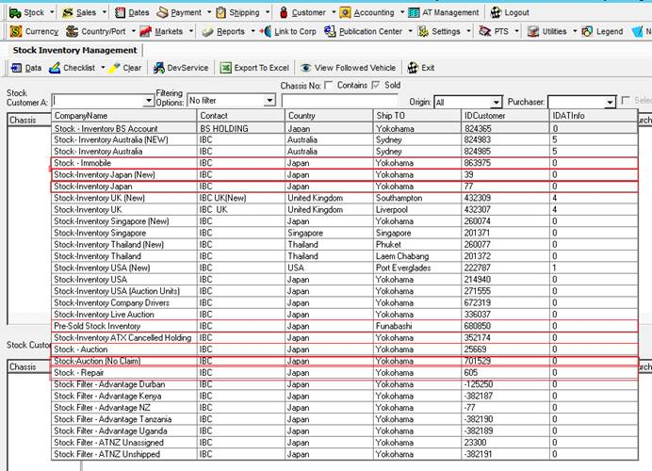

- PRICING

1. Pricing

  - Auction Price; The price that the vehicle was purchased for at auction.
  - Auction Fee; The auction fee invoiced from the auction
  - Purchase Price; Auction Price + Auction Fee
  - Car Cost;
The Car Cost is the price needing to be set by the Purchaser to reflect the Market Value (MV) of the vehicle plus or minus of Purchase Price.

Figure 2
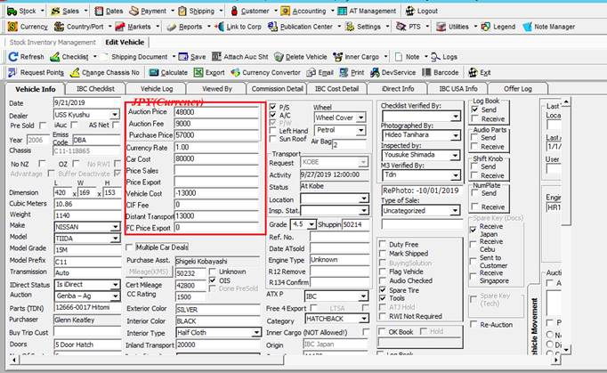

2. IBC Cost Details;

a. “Estimated” Cost Details;

This is what IBC uses to estimate what the total export costs will be incurred in order to export a selected vehicle to the end customer. Allowance has been made for costs overruns to ensure that vehicles exported are not sold at a loss.

b. “Accounting” Cost Details;

When all the associated costs have been entered into IBCs accounting system this overrides any “Estimated” costs details therefore allowing IBC to accurately account for all costs associated to export that vehicle to the end customer.

Figure 3

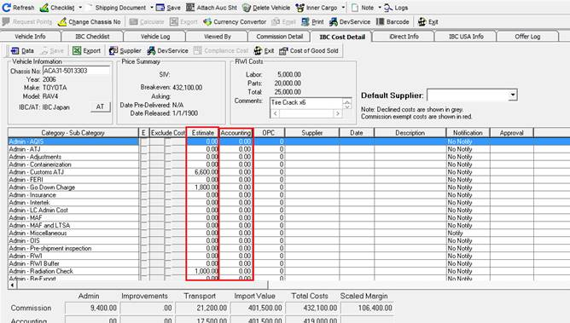

3. IBC Pricing for Customers;

a. Asking Price;
This is the price that IBCs global customers based on their market settings see IBC inventory pricing when logging into IBCs website. There are Car Cost + Local Transport + Freight + Inpsection (if necessary, depend on the country you want to ship to ) + IBC Margin. Website price is always based on the car cost. If you put your car cost as 0 (Zero) then web price will be comprises of Local Transport + Freight + Inspection + IBC Fees which will be way too low. That’s why updating your car cost and monitoring your purchase is very important.

- Sales Floor;
Any offer Prices made below Sales Floor are to be approved by the purchaser prior to selling. After expiry of 60 days, it can be approved either by purchaser or by management. There is always buffer between sales floor and Web site price. Sales floor is internal term and its only known to IBC employees. Outsider can only see web site price. Sales Floor price is set by purchaser to allow seller to bargain.

- SIV (Stand in value)
This is the stand in valued allowing for IBCs minimum expected margin required to retain a minimum profit. It is calculated by adding various costs to purchase price ie purchase price + local Transport + Freight + Inpsection (if necessary) + IBC Margin + any extra costs(if needed)

- Break Even;
IBC costs. It is calculated by adding various costs to purchase price ie purchase price + local Transport + Freight + Inpsection (if necessary any extra costs(if needed). No margin included. .

Figure 4

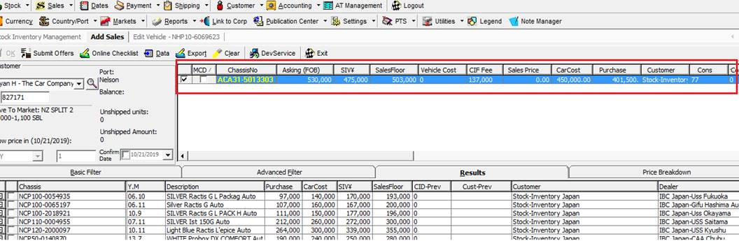

4. Vehicle Confirmation rules;

  - Accounts are to be instructed when any vehicles are to be confirmed into customers’ accounts by emailing “IBCAccounts@ibcjapan.net". Emails will go to Accounts PI and can be attended immediately.

  - Accounts will first check to see that the purchaser has approved of selling the unit below Sales Floor.

  - Above example is for a NZ customer. For NZ customer – terms are different, company margin and others costs are always set in their fee structure. As you can see this customer has market setting of “NZ SPLIT 2 60,000-1,100” . in this case base is car cost, - Car cost plus 60,000yen (IBC Margin ) becomes FOB Plus OFS of 1100$. Make sure that your car cost is not below purchase price. For all Non NZ customer you need to follow Sales Floor, SIV and BEP. GAP between SIV and SF is bargaining amount which purchaser sets by adjusting car cost. Higher the car cost gives you more room for bargaining but be realistic.

-------------------------------------------End-------------------------------------

