IBC JAPAN LTD.
STANDARD OPERATING PROCEDURES
Controlled No.: SOP-001-102019
Dated 24 October 2019 Rev. 0

Table of Contents Pages

- Stock Inventory 2 - 3

- Stock Inventory Customers
- Stock-Inventory Japan (New) CID; 39
- Stock-Inventory Japan CID; 77
- Stock-Repair CID; 605
- Pre-Sold Stock Inventory CID; 680850
- Stock-Immobile CID; 863975
- Stock-Auction (No Claim) CID; 701529
- Stock-Auction (No Claim) CID; 701529

- Pricing
- Pricing 4
  - Auction Price
  - Auction Fee
  - Purchase Price
  - Car Cost

- IBC Cost Details 4 - 5
  - “Estimated” Cost Details;
  - “Accounting” Cost Details;

3. IBC Pricing for Customers 5
a. Asking Price;
b. Sales Floor;
c. SIV (Stand in value)
d. Break Even;

- Vehicle Confirmation 6

History Log
Date issued/Revision | Description | Author
24 October 2019 | Updated SOP for Inventory and Pricing | Jojo Hemi

- STOCK INVENTORY

- Stock Inventory Customers;

  - Stock-Inventory Japan (New) CID; 39;
All units purchased are to remain in this account and will be the duty of the AM/BS/AAM/MM to move the vehicle to other Stock-Inventory customers.

  - Stock-Inventory Japan CID; 77;
Units moved into this account will be viewable for sale to IBCs global customer base. Prior to moving units from CID; 39 to CID; 77 the vehicles CarCosts, sales floor must be set to reflect the vehicles asking price to IBCs global customers. Cars moved into CID; 77 must be moved to other accounts before the end of the day.

  - Stock-Repair CID; 605;
All units purchased that require repairs must be moved into CID; 605. Once vehicles are repaired the AM/BS/AAM/MM will be informed and the vehicles CarCost, sales floor must be set to reflect the vehicles asking price to IBCs global customers. All cars that are repaired must be moved into CID; 77 the same day that the BS/AM/AAM/MM has been notified.

  - Pre-Sold Stock Inventory CID; 680850;
All units purchased for customers are to be moved into the CID 680850; This account is to be used as a short term temporary holding account until such time as the AM has had the opportunity to make contact with the customer to finalize the sale of the purchased unit.

  - Stock-Immobile CID; 863975;
All units that have been purchased for scrap.

  - Stock – Auction CID; 25669;
All units that have been prepared to be re-auctioned in Japan.

  - Stock-Auction (No Claim) CID; 701529
All units that have been prepared to be re-auctioned in Japan with and auctioned as a “No Claim” vehicle

Figure 1

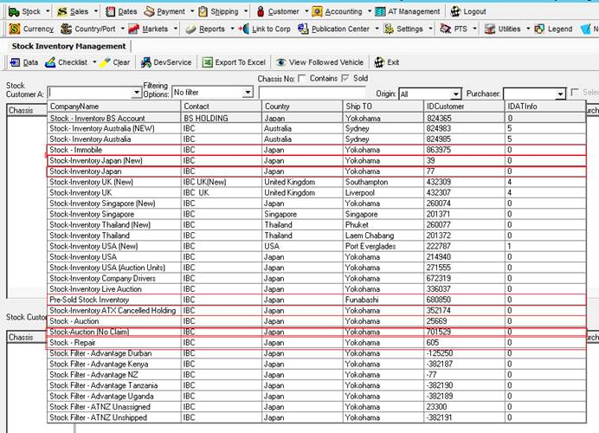

- PRICING

1. Pricing

  - Auction Price; The price that the vehicle was purchased for at auction.
  - Auction Fee; The auction fee invoiced from the auction
  - Purchase Price; Auction Price + Auction Fee
  - Car Cost;
The Car Cost is the price needing to be set by the BS/AM/AMM/MM to reflect the Market Value (MV) of the vehicle plus or minus of Purchase Price. IBC Estimated Costs Admin Details uses Car Cost to price vehicles onto the customers

Figure 2
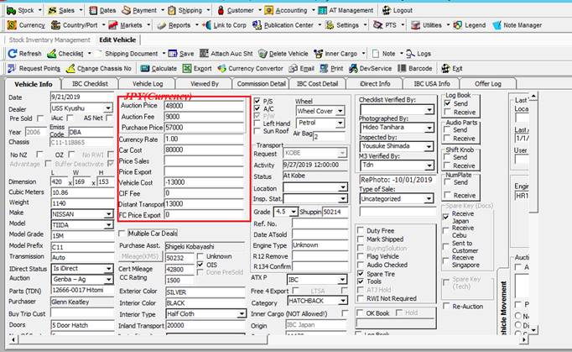

2. IBC Cost Details;

a. “Estimated” Cost Details;

This is what IBC uses to estimate what the total export costs will be incurred in order to export a selected vehicle to the end customer. Allowance has been made for costs overruns to ensure that vehicles exported are not sold at a loss.

b. “Accounting” Cost Details;

When all the associated costs have been entered into IBCs accounting system this overrides any “Estimated” costs details therefore allowing IBC to accurately account for all costs associated to export that vehicle to the end customer.

Figure 3

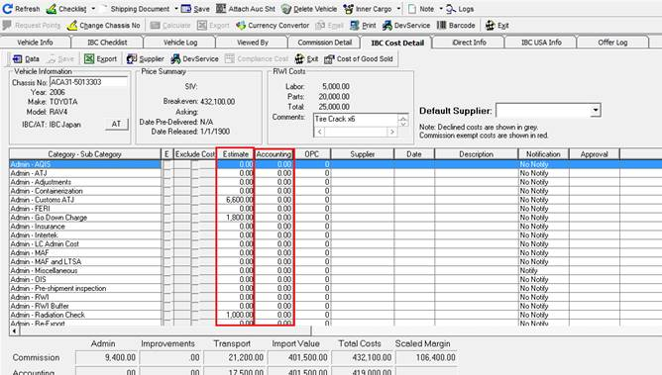

3. IBC Pricing for Customers;

a. Asking Price;
This is the price that IBCs global customers based on their market settings see IBC inventory pricing when logging into IBCs website.

- Sales Floor;
Prices made below Sales Floor are to be approved by the purchaser prior to selling.

- SIV (Stand in value)
This is the stand in valued allowing for IBCs minimum expected margin required to retain a minimum profit.

- Break Even;
IBC costs. No margin included.

Figure 4

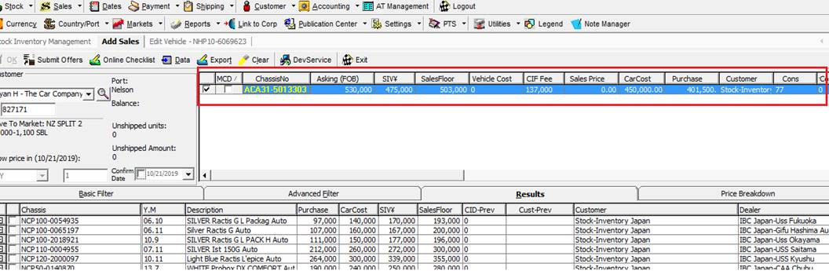

4. Vehicle Confirmation rules;

  - Accounts are to be instructed when any vehicles are to be confirmed into customers’ accounts by emailing “IBCAccounts@ibcjapan.net". Emails will go to Accounts PI and can be attended immediately.

  - Accounts will first check to see that the purchaser has approved of selling the unit below Sales Floor.

  - BS/AMs/AMM/MM are encouraged to communicate internally and seek approval on selling another purchasers vehicle prior to emailing accounts.

-------------------------------------------End-------------------------------------

