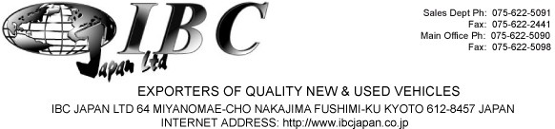

PROFORMA INVOICE

DATE: 7/16/2019 8675511

Buyer/Importer:
Payment Condition:

T.R.P.K. THENNAKOON
158/42X, NHDA HOUSING SCHEME, WELAGEDARA UYANA, WELANGOLLA WATTA, KURUNEGALA,
SRILANKA
Irrevocable Letter of Credit against Proforma Invoice value. Payable At Sight and Reimbursement Bank in New York in case of USD, Japanese yen in Tokyo.
T/T Reimbursement is allowed.
Beneficiary/Shipper: L/C Condition:
IBC Japan Ltd
64 Miyanomae-cho Nakajima Fushimi-ku Kyoto 612-8457 Japan
L/C Advising Bank:
Terms of Trade:
LC AT Sight
MUFG Bank , Ltd.
Fushimi branch, Kyoto, Japan SWIFT code : BOTKJPJTOSA
Insurance Policy/Certificate states "Excess of JPY50,000" therefore, delete "Irrespective of Percentage" in Insurance clause or advise the Issuing bank not to claim discrepancy.

Port of Loading:
Latest Shipment Date:

Any Port in Japan
45 days after L/C issuance

Port of Discharge:
Period for Presentation:

Any Port, Sri Lanka
Within 15 days after shipment

No. | Chassis No. | Make | Model | CountryOf  Origin | 1st Year/Month  of Registration | FOB Price | Freight | Insurance | Amount
1 | KSP130-2217072 | TOYOTA | VITZ | Japan | 2017 November | 890,000 | 55,000 | 5,000 | JPY 950,000

Buyer
TOTAL
CIF Sri Lanka in JPY

IBC Japan Ltd
JPY
950,000

