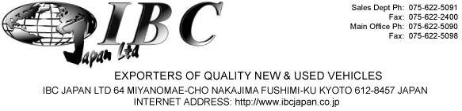

30th May 2019

To Whom it May Concern

Re : Reprint of MR2A

Please reprint MR2A for the following Vehicle and release it to 2 Cheap cars Ltd as they are the lawful owner of this vehicle.

Make : MAZDA

Model : Axela

Colour : Grey

Year : 2010

Chassis: BL5FW-107747
VIN: 7AT0C13JX19107747

Thank you.

Tom Nambiar

IBC Japan
Account Department

